TiltGroup Wrangler Instructions

Tiltgroup Wrangler is designed to divide a dataset collected with Leginon into image shift groups. Unlike software such as SerialEM, the image shift is not recorded in the filenames. Image shift beam tilt calibrations need to have been done already in Leginon. This hardware correction works very well. However, if the cvalibrations are off, then grouping can improve resolution. This also serves as a test that the calibrations are good.

Installation

- tiltgroup_wrangler.py has the following dependencies:
- tkinter
- numpy
- matplotlib
- scikit-learn
- dataset (Cryosparc library, only needed for cryosparc export)
- pandas (needed for cryosparc export)

The easiest way to get all of the prerequisites is to use the EMAN2 anaconda python environment. This will have everything apart from dataset and pandas. Pandas can be installed with pip, and the dataset library needs to be installed from a Cryosparc installation. A Cryosparc license is needed for this library.

Prerequisites

On the CTF summary page, download “star file with expected beam tilt for Relion 3.0”. If you look at the file, you should see columns for _rlnBeamTiltX and _rlnBeamTiltY, and the values for each micrograph are recorded in milliradians (mrad). If they are all 0, then the image shift beam tilt calibrations were not performed in Leginon. In this case, the current program will not work for grouping. In principle, one could download the image shift values, in microns, and use these as inputs, but this has not been tested.

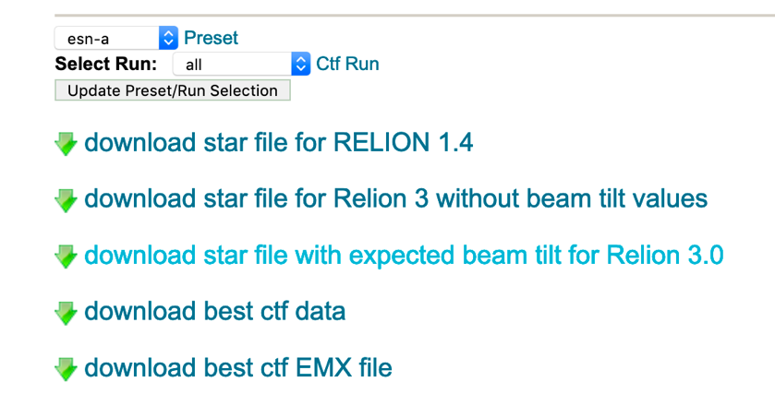

Running
Once the correct python environment is loaded, start the program with tiltgroup_wrangler.py
The program is designed to only enable buttons once things are ready.

Use “Select File” to browse to the downloaded star file, select it, then click “Read File”

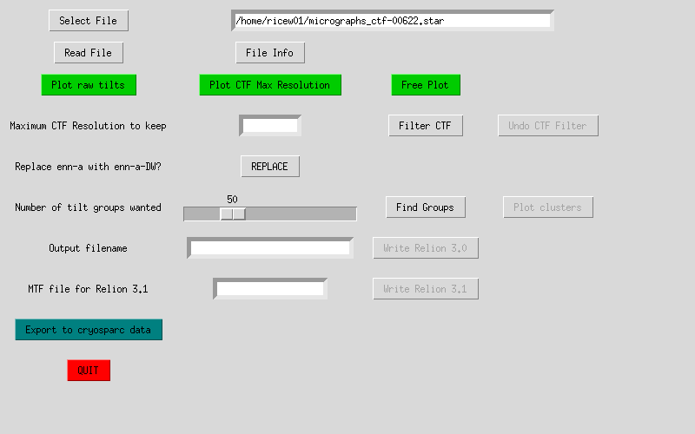

The File Info button will pop up a new window listing the header information as well as a sample file name.

“Plot Raw tilts” will bring up a plot of the beam tilts in X and Y.
“Plot CTF Max Resolution” will make a plot of the maximum Thon ring fitting as determined by CTFFIND4 and/or Appion. You can use this plot to discard images, if desired. This is done through the “Filter CTF” button.
“Free Plot” lets you choose various other Relion values to plot.

Often, CTF is determined on non-dose-weighted images whereas particles are picked on dose weighted images. In Leginon/Appion parlance, these are often called “enn-a” and “enn-a-DW” respectively. The “Replace” button will change “enn-a” to “enn-a-DW” in the output star file. After clicking this, check that the file names are fixed using the “File Info” button. This also works with “esn” images.

The grouping is controlled by a slide bar. Slide to the desired number of groups. If the grouping is obvious by eye, choose that number, otherwise, choose a large number (50-100) of groups. Click “Find Groups” to group them, and “Plot Clusters” to visualize.

Once you are satisfied with the grouping, enter a filename for output and then click “Write Relion 3.0” to save the file. It will have the tilt groups added to the micrographs, and the micrograph name will have been replaced with DW if that option was performed.

Export to Cryosparc

If you wish to process the groups in Cryosparc, click the “Export to cryosparc data” button to bring up that window.
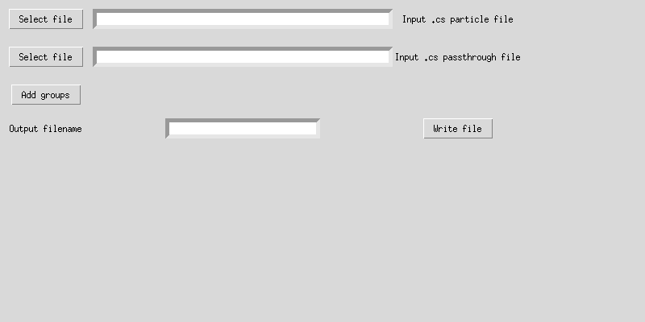

Because Cryosparc saves various values in both the .cs particle file and the passthrough file, depending on how things were processed, both files are needed to export the data. You will eventually need to write back to the Cryosparc processing folder, so you need read and write access for this.
Use the selection buttons to browse to the appropriate cryosparc files. These may come from 2D or 3D processing. It is essential that the particles are associated with micrographs of the same filename. If particles were uploaded to Cryosparc without being associated with micrographs, the micrograph filenames will have been lost. In this case, it’s easiest to export the cryosparc particle stack to Relion using the pyem tool csparc2star.py, then re-importing while associating them with micrographs. It is easiest if this was already done.

Clicking the “Add Groups” button will associate the groups with the relevant cryosaprc file.
An information window will pop up telling you which file has the CTF information:
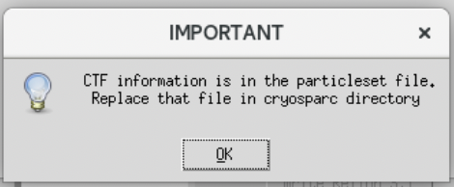
It will also tell you how many particles were not able to be matched to micrographs. These mismatched particles will go to a separate group. The main reason for mismatch is that Appion was not able to find a reliable CTF fit. If all of them would not match, it is very likely that there is a filename mismatch between the downloaded star file from Appion and the micrographs being used in Cryosparc. Check the star file and edit the filenames as necessary. You will need to re-run. Another possibility is that the particles were not associated properly with the micrographs. The easiest way to sort it out is to convert the Cryosparc particles to star and examine the file.

When the grouping is done, you can write a filename for export. Be sure to give it a “.cs” extension since it will be in that format.

To actually have the groupings applied, you need to replace the original Cryosparc file with the file just output by tiltgroup_wrangler.py. You may need to ask your system administrator for help in this. Depending on the output, replace either the particles.cs file or the passthrough.cs file with the file just written. I suggest you first save a backup copy of the original file in case something went wrong.

You should now be able to run Global CTF Refinement in Cryosparc on the new groups. Choose the particles file you just replaced as input. You should see it doing may groups, as opposed to only one.

