Making a Template using the Appion Pipeline
A template is a common view of your particle that is used for reference. Templates are typically averages of a combination of individual particle images. Making a template for your particle is important because it is used as a reference for both particle picking and particle alignment. When going through all of these steps ensure to include your initials in the Run Names (we will discuss that later)

The steps to making a template are:
- Manual picker
- CTF estimation
- Stack creation
- Alignment

What do you need to know before starting?
- Particle size
- Image pixel size
- Was the sample on ice or carbon

What size is my particle and where to start?
- http://172.21.9.162/ami/
  - Note: This link is only available from on-campus and it is not available from on-campus computer labs including the Resource Center. It only available from department computers and your laptop via RU WIFI. I am working to fix this.
- Enter the image viewer, by clicking on the link:
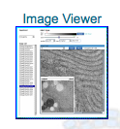
- In the drop down menu on the top left, select your project- BIOL 364/464
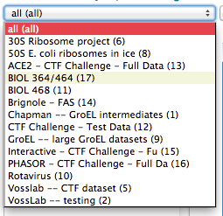
- Next select on the center drop-down menu your own experiment
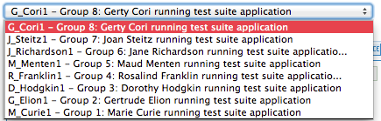
- There is now a list of images on the left for your dataset:
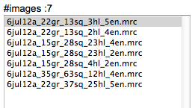
- You can click on them and watch them change in the main window.
- Record the pixel size in Ångstroms per pixel:
  - Note: an Ångstrom is a standard unit of measure it is equal to 10⁻¹⁰ meters or 0.1 nanometers. The Ångstrom is the preferred unit in structural biology because it about the size of an atom or the length carbon-carbon bond.

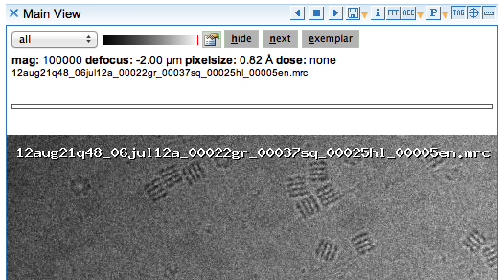
- Click on the image and a new window will pop up
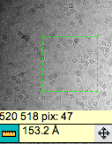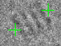
- There will be a small ruler icon in the bottom left corner
- Click each side of your particle
- The particle diameter will appear near the ruler
- This number is in Angstroms (Å)

Typical particle size
- Gro-EL 180 Å
- Ribosome 180 Å
- Virus 300 Å

Enter Appion
- Go back to the Image Viewer and Click [processing] at the top to enter the Appion pipeline (see image below)
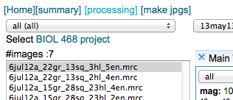

Manual picker

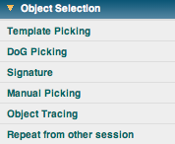

For more for information:
http://ami.scripps.edu/redmine/projects/appion/wiki/manual_picking

Parameters for Manual Picker
- Go to the page
- Enter a description into the Run Name box
- Enter particle diameter 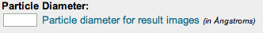
- Change low pass filter to 30

Manual picker is used for picking Gro-EL and virus particles.

Manual picker is the process of manually picking the particles from your data set. Dr. Voss will upload these images. A general idea of the size of the particle is needed to start the process. When dealing with Gro-EL a good starting particle diameter is 180.
When everything is set, just click just show command button near the bottom of the screen. This will show a command and it will need to be copied and pasted into the terminal. Press enter. This will allow the program to run.

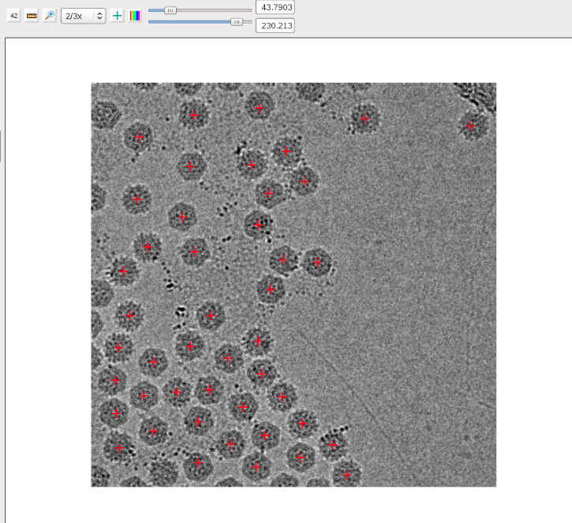

Roughly 100 particles from the images should be picked.

When done click the forward button  Your data is saved every time you click the forward button. Make sure you pick a total of 100 particles doesn't matter how many images you pick from. Once the picking is completed this will automatically be saved to a file that can be used to further progress through making a template

CTF (Contrast Transfer Function) estimation

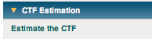
- Log in: Vosslab
- Password: Phys-554

For more for information:
http://ami.scripps.edu/redmine/projects/appion/wiki/Ace_2_estimation

The next step is running CTF correction. The CTF uses filters to distort the image. A high pass filer subtracts the background of the image, while the low pass filter blurs the image. In the Appion Pipeline, CTF correction is done via the program called ACE2.

- Click the ACE2 estimation link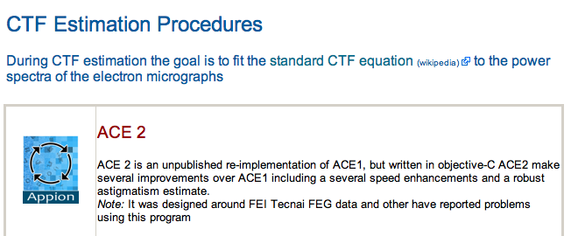
- Leave all the settings alone unless Dr. Voss states otherwise

Three Separate Steps
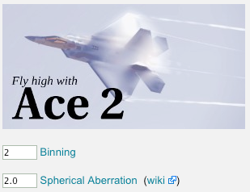
Preform three separate runs:
- Enter Ace2- Bin by 1 then click run
- Reenter Ace2 gage- Bin by 2 then click run
- Reenter Ace2 page- Bin by 4 then click run
- Allow for each of the binnings to complete

Stack creation

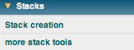

For more for information:
http://ami.scripps.edu/redmine/projects/appion/wiki/stack_creation

A stack is a collection of images stacked together.

Creating a Stack
- Select stack creation
- Input the box size of the particle

Determining box size
- Particle size of 300 Å (measured from earlier)
- Pixel size of 1.63 Å / Pixel (in image viewer Particle Size= 184 pixels
- We want 150%, =276 pixels
  - 276 is not a “nicely rounded” number so use 256 or 288
  - Select the closest number to your box size
- The binning number. Generally 2, is a good number for the binning.
- Binding by one gives big images and a lot of detail, bin by 4 give a small image and little detail. Binning by 2 give the right ratio
- The filter must be changed to create a stack.
- Select ACE2 Wiener Filter Whole Image.
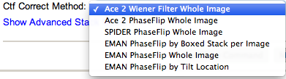
- Invert image density
  - White and black particles. We always want white particles because the program always expects there to be white particles.
  - If dealing with particles in ice then must invert image
- CTF corrects particle images
- Also, select where you got your particles which method of picking did you use? If you don't know, go to object collection.
No quotes! When writing in the description box. This is the time to describe what you are doing like you would in a lab notebook

The Ace 2 Wiener Filter Whole image does a better job at correcting the CTF
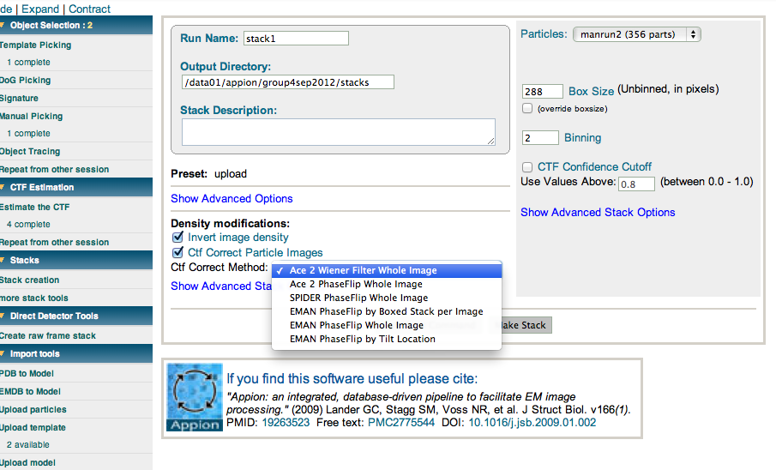

Analyzing your Stack

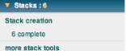
- Once the stack is complete, Click on 6 Complete
- Select your stack and click on Stack info.

Alignment

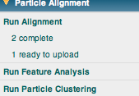

For more for information:
http://ami.scripps.edu/redmine/projects/appion/wiki/alignment

When a stack is created is a series of images of your particles stacked together. They must be rotated and shifted to align together to obtain a nice average image. We want the alignment to finish in the class period and we want it to take 10 minutes.
If 10 minutes are chose for the first iteration it will take 20-30 minutes in total

- Angle increments determine:
  - Smaller the angle will give a better alignment

Things that affect your time:
- Click run alignment under the particle alignment tab on the left hand side of the screen
- Select Xmipp Maximum Likelihood Alignment
- Enter a description in the description box
- Changed the unbinned clip diameter to your particle size
- Select a particle binning of 2
- Enter the number of references (number of averages)

- You can do more than three but be conscious of time
  - Gro-EL has 3 references
  - Ribosome-3
  - Virus- 3
- A good number for the maximum number iterations is 15

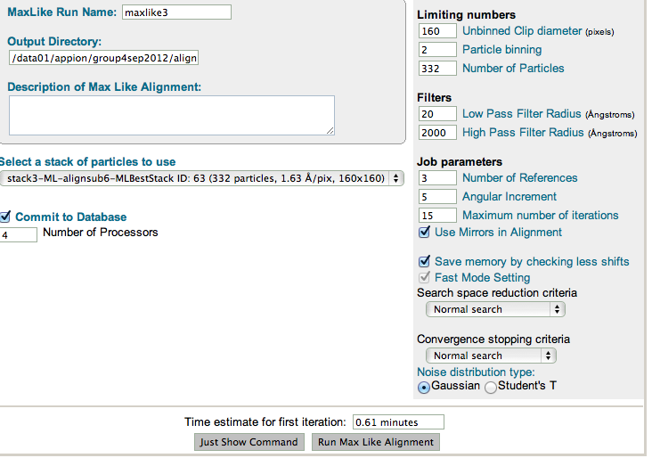

Upload Alignment
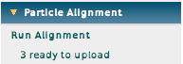
- Click on “ready to upload”
- Note: other students in the class with have their alignments will show up along with yours
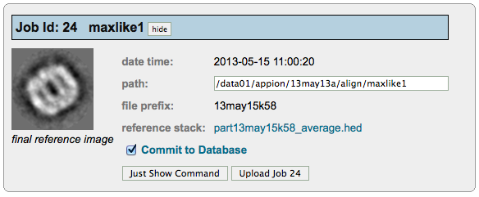
- take a look at the averages to see if it produced something that looks like a particle by clicking on the reference stack link, in this case “part13may15k58_average.hed”
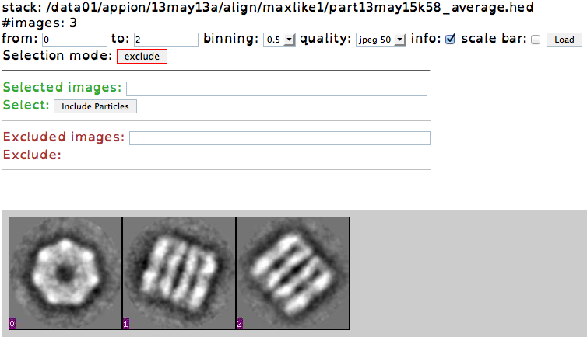
- if the stack is good (like example above) go back to the previous screen and click on the button“Upload Job” to upload the alignment run

Assess the Alignment
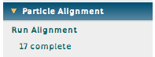
- Once an aligned stack has been uploaded, go to the alignment page by clicking on the “17 complete” in the example above
- this screen tells you detailed information on the run including the pixel size and the box size.
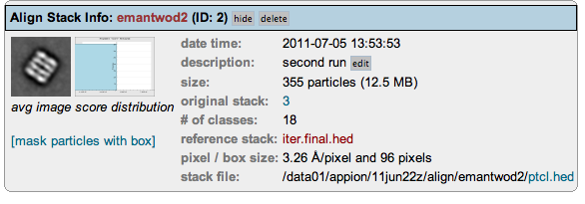
- Click on link to get the number of average particles
  - Note: you may also click on “stack file” link to see the individually aligned particles:
- The reference stack should look something like this:
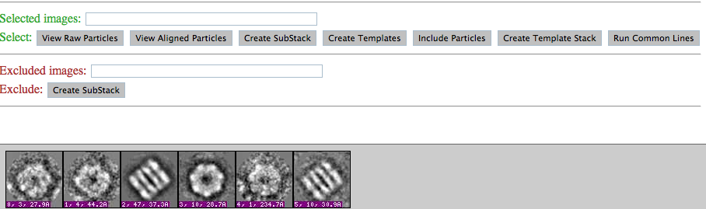

- Change selection mode from exclude to select
  - the word “select” should now be in green
- Select the references that you want to be a template
- the particle will now have a green outline
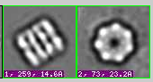
- Additionally the numbers of the references will show up in the selection box:
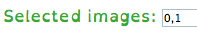
- Do not select the first reference because it is ugly
- Select create templates 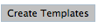 button
  - Note: Do NOT select the create template stack 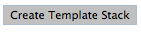 button

Upload a template
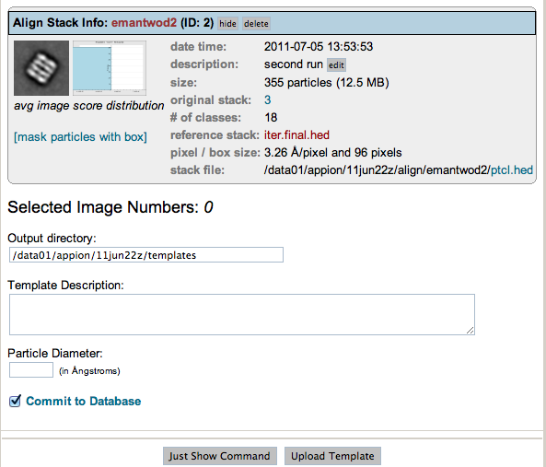

- Upload a template page

  - Selected image numbers should match the previous page
- Write a description in “Template description”
- Enter particle diameter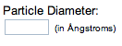
- Click commit to database 

Once the template is completed, go to the side bar on the left hand side, under import tools and click on word available 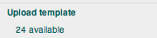
One will be available, after clicking on this your new template will appear, this means you were successful at making a template



