**I would like a page that had all of this data in one place. Right now it is scattered over three different places and likely inaccurate. If it all cannot be done easily and at once then please let’s at least get some of it in place ASAP. I also understand that these queries might be very long and thus might only want to run them on request or once a month of something. That is fine but please let’s move in this direction.**

**Leginon Statistics:**

# projects :

# expt sessions with #images > 10) [this excludes irrelevant test sets etc. I hope] :

# images :

# tomographic tilt series:

total size of images (i.e. disk space) :

size of Leginon DB :

number of DB records :

**Appion Statistics:**

# projects :

# expt sessions with processed data) [this excludes irrelevant test sets etc. I hope] :

# particle picking runs:

# particles picked:

# ace runs:

# particle stacks:

# classification runs:

# classes :

# classified particles:

# RCT models:

# tomograms processed:

# 3d maps:

**Then some graphical data:**

A table showing:

|  |  |  |  |  |
| --- | --- | --- | --- | --- |
| **Project name** | **# expts** | **Date of last experiment** | **Number of processing runs** | **Date of last processing run** |
| name | numebr | date | number | date |
|  |  |  |  |  |
| Etc. | etc | etc | etc | etc |
| **Total # projects** | **Total #expts** | **Last Date of last experiment** | **# Number of processing runs** | **Last Date of last processing run** |

One day it would be nice to make these sortable on any of the column headings.

And then some graphs:

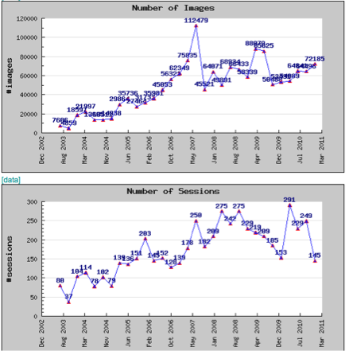

Then I’d also liekt he same as a running sum for Leginon images and sessions and for Appion sessions and runs.